ED 120-150-200 Special
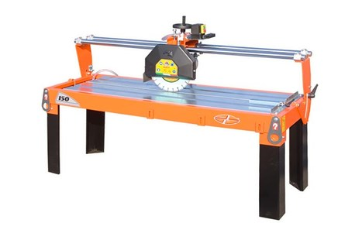

Technical Data
ITEM | MOD. |  |  | 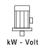 | 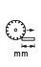 | 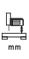 | 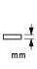 | 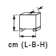
120311 | MANTA 120 SP | 350 | 1400 | 2,2-230 | 1200 | 210 | 110 | 165x66x77 | 168
120301 | MANTA 120 SP | 350 | 1400 | 3,6-400 | 1200 | 210 | 110 | 165x66x77 | 168
120305 | MANTA 120 SP | 450 | 2800 | 4-400 | 1200 | 210 | 150 | 165x66x77 | 168
120335 | MANTA 150 SP | 450 | 1400 | 2,2-230 | 1500 | 210 | 150 | 197x88x77 | 210
120354ED | MANTA 150 SP | 450 | 2800 | 3-400 | 1500 | 210 | 150 | 197x88x77 | 185
120400ED | MANTA 150 SP | 450 | 2800 | 4-400 | 1500 | 210 | 150 | 197x88x77 | 216
120457 | MANTA 200 SP | 450 | 1400 | 2,2-230 | 2000 | 210 | 150 | 250x88x77 | 260
120455 | MANTA 200 SP | 450 | 1400 | 3,6-400 | 2000 | 210 | 150 | 250x88x77 | 260
120451 | MANTA 200 SP | 450 | 2800 | 4-400 | 2000 | 210 | 150 | 250x88x77 | 260
120356 | MANTA 150 SP | 350 – 25.4 | 2800 | 2.2 – 230 | 1500 | 210 | 150 | 197x88x71 | 210
120458 | MANTA 200 SP | 350 – 25.4 | 2800 | 2.2 – 230 | 2000 | 210 | 150 | 250x88x77 | 260
* Voltage and power upon request on all models
** All versions have chrome bars, 50 mm in diameter

