ED 50-600
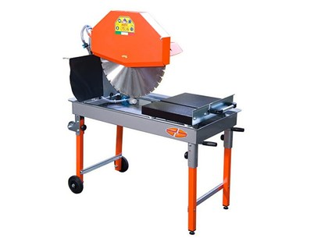

Technical Data
ITEM | MOD. | 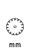 |  | 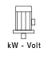 | 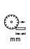 | 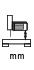 | 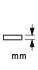 | 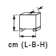 | 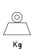
120163 | MANTA ED 50-600 | 600 | 1400 | 4 - 400 | 400 | 330 | 230 | 123x61,5x145 | 89
120171 | MANTA ED 50-600 monofase | 600 | 1400 | 2.2 - 230 | 400 | 330 | 230 | 123x61,5x145 | 89

