ED 50
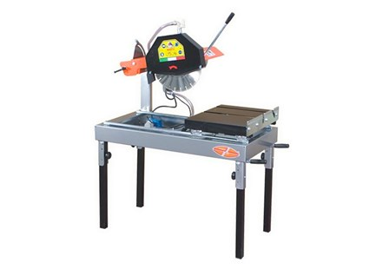

Technical Data
ITEM | MOD. |  |  | 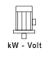 | 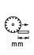 | 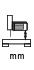 | 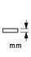 | 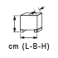 | 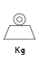
120100 | MANTA ED 50 | 350 | 2800 | 2.2 - 230 | 600 | 210 | 110 - 200* | 112x64x64 | 80
120102* | MANTA ED 50 - 400 | 400 | 2800 | 2.2 - 230 | 600 | 210 | 125 - 200* | 114x64x78 | 80
120103 | MANTA ED 50 - 450 | 450-25,4 | 2800 | 3-400 | 600 | 210 | 150 - 200* | 114x64x78 | 80
* Two-passage cuts for stone slabs 20 cm. thick.

