EV
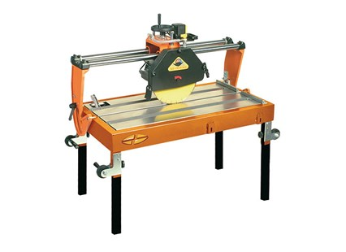

Technical Data
ITEM | MOD. |  |  | 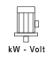 | 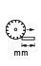 | 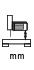 | 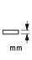 | 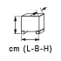
120158ED | MANTA EV 65-450 | 450 | 2800 | 2,6 - 230* | 650 | 160 | 150 | 124x66x77 | 90
120206ED | MANTA EV 85-450 | 450 | 2800 | 2,6 -230* | 850 | 160 | 150 | 144x66x77 | 105
120256ED | MANTA EV 100-450 | 450 | 2800 | 2,6 - 230* | 1000 | 160 | 150 | 157x66x77 | 120
120308ED | MANTA EV 120-450 | 450 | 2800 | 2,6 -230* | 1200 | 160 | 150 | 177x66x77 | 160
* 3 kW - triphase version is also available

