Inox 150-200 LX SA Plus
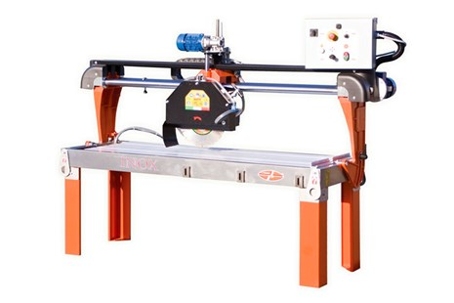

Technical Data
ITEM | MOD. | 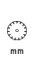 | 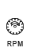 | 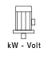 | 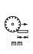 | 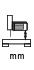 | 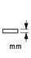 | 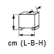 | 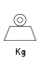
120274 | MANTA INOX 150 LX SA PLUS | 450 | 2800 | 4 - 400 | 1500 | 180 | 150 | 225x90x112 | 240
120275 | MANTA INOX 150 LX SA PLUS | 450 | 1400 | 4 - 400 | 1500 | 180 | 150 | 225x90x112 | 240
120276 | MANTA INOX 200 LX SA PLUS | 450 | 2800 | 4 - 400 | 2000 | 180 | 150 | 275x90x112 | 255
120277 | MANTA INOX 200 LX SA PLUS | 450 | 1400 | 4 - 400 | 2000 | 180 | 150 | 275x90x112 | 255
120284 | MANTA INOX 120 LX SA PLUS | 450 | 2800 | 4 - 400 | 1200 | 180 | 150 | 195x90x112 | 220
120285 | MANTA INOX 120 LX SA PLUS | 450 | 1400 | 4 - 400 | 1200 | 180 | 150 | 195x90x112 | 220
* Voltage and Power upon Request
