Inox Series
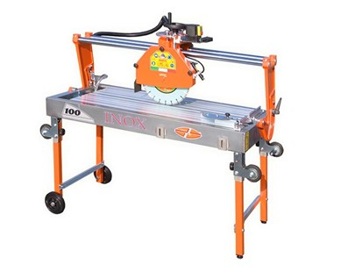

Technical Data
ITEM | MOD. | 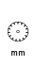 | 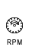 | 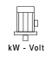 | 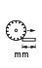 | 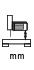 | 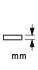 | 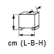 | 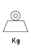
120261 | MANTA 85 INOX** | 350 | 2800 | 2,6-230* | 850 | 160 | 110 | 144x66x77 | 96
120260 | MANTA 100 INOX** | 350 | 2800 | 2,6-230* | 1000 | 160 | 110 | 157x66x77 | 106
120262 | MANTA 120 INOX** | 350 | 2800 | 2,6-230* | 1200 | 160 | 110 | 177x66x77 | 120
120263 | MANTA 150 INOX** | 350 | 2800 | 2,6-230* | 1500 | 160 | 110 | 197x66x77 | 166
* Triphase version is also available
** Self-bracking motor

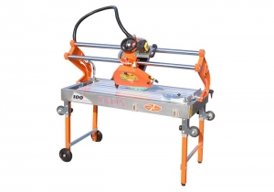 | 