Laser (1)
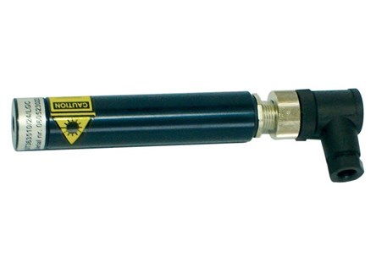

Technical Data
ITEM | MW | BATT
020092 | 1 | STILO AA
020078* | 1 | STILO AA
* With holder.

