LX TB
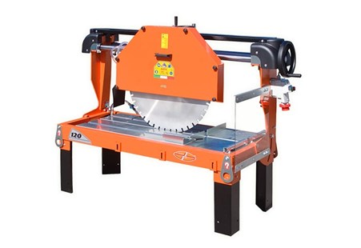

Technical Data
ITEM | MOD. | 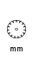 |  | 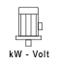 | 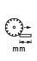 | 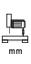 | 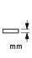 | 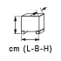 | 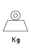
130204ED | MANTA LX TB 120-750 MONOFASE | 750 | 900 | 2,6 -230 | 700 | 330 | 300 | 195x80x90 | 190
130200ED | MANTA LX TB 120-750 TRIFASE | 750 | 1400 | 4 - 400 | 700 | 330 | 300 | 152x80x90 | 190
130203ED | MANTA LX TB 120-800 TRIFASE | 800 | 1400 | 5,5-400 | 600 | 360 | 325 | 195x80x90 | 200
130202ED* | MANTA LX TB 120-1000 TRIFASE | 100 | 950 | 7,5-400 | 550 | 450 | 400 | 195x80x103 | 270
140159ED | MANTA LX TB SA 120-800 TRIF. | 800 - 40 | 1400 | 5,5 - 400 | 600 | 360 | 325 | 195x80x90 | 200
140162ED* | MANTA LX TB SA 120-1000 TRIF. | 1000 - 60 | 950 | 7,5 - 400 | 550 | 450 | 400 | 195x80x103 | 270
* No tilting head for 45° cuts
