Roltafel
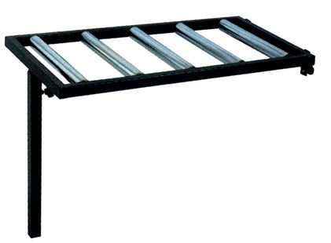

Technical Data
ITEM | AVAILABLE ON | Kg
17M000 | ALL MODELS | 13

