Scorpione
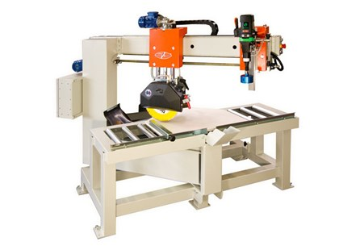

Technical Data
ITEM | MOD. | 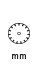 | 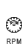 | 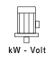 | 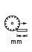 | 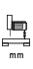 | 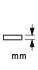 | 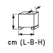 | 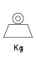
122002 | SCORPIONE BASIC MONOFASE | 350 | 2800 | 2,2-230* | 700(90°)-600(45°) | 140 | 110 | 185x133x187 | 400
122000 | SCORPIONE BASIC | 350 | 2800 | 4-400* | 700(90°)-600(45°) | 140 | 100 | 185x133x187 | 440
122003 | SCORPIONE SA MONOFASE | 350 | 2800 | 2,2-230* | 700(90°)-600(45°) | 140 | 100 | 185x133x187 | 440
122004 | SCORPIONE SA | 350 | 2800 | 4-400* | 700(90°)-600(45°) | 140 | 100 | 185x133x187 | 450
122011 | SCORPIONE SA TRIFASE | 350 | 1400 | 3.6-400* | 700(90°)-600(45°) | 140 | 100 | 186X133X187 | 450
* Voltage and Power upon Request

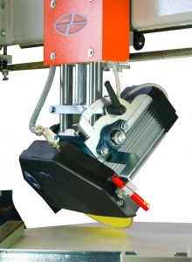 | 