Side stop
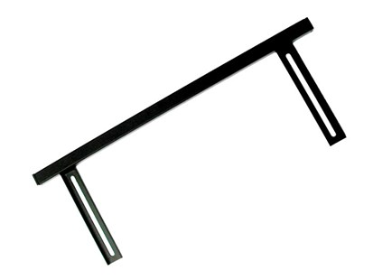

Technical Data
ITEM | AVAILABLE ON
17M002 | MANTA 65-85-100
17M003 | MANTA 120-150-200-ECO
17M009 | SPECIAL
17N000 | MINI MANTA

