TP
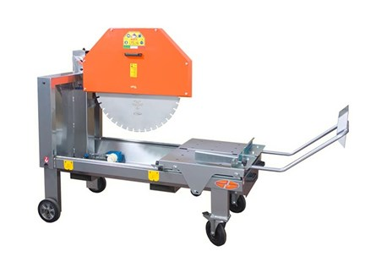

Technical Data
ITEM | MOD. |  |  | 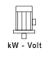 | 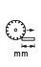 | 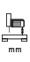 | 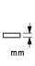 | 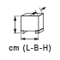 | 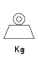
130220ED | MANTA TP 650 | 650 | 1400 | 4 - 400 | 600 | 440 | 250 | 165x95x138 | 245
130221ED | MANTA TP 750 monofase | 750 | 900 | 2.6 - 230 | 530 | 440 | 300 | 165x95x142 | 260
130222ED | MANTA TP 750 | 750 | 1400 | 4 - 400 | 530 | 440 | 300 | 165x95x142 | 255
130223ED | MANTA TP 800 | 800 | 1400 | 5,5 - 400 | 500 | 440 | 325 | 165x95x142 | 260
130224ED | MANTA TP 1000** | 1000 | 900 | 7,5 - 400 | 450 | 410 | 400 | 165x95x152 | 310
130227ED | MANTA TP 650 monofase | 650 | 900 | 2,6 - 230 | 600 | 440 | 250 | 165x95x138 | 245
** Self-braking motor

