

**CM 150**

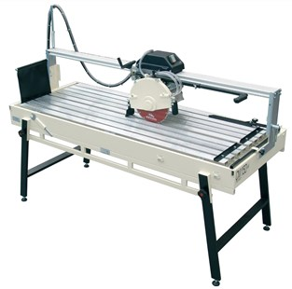

 Download hier de productfolder

|  |  |
| --- | --- |
|  |  |
|  |  |