Boorfrezen
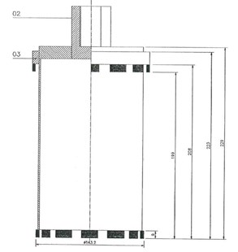
D250104 | Boorfrees Ø143,2/154mm 1¼''UNC 250mm NL
D250106 | Boorfrees Ø153,4/175mm 1¼''UNC 250mm NL
D250107 | Boorfrees Ø179,2/191mm 1¼''UNC 250mm NL
D250108 | Boorfrees Ø188,6/212mm 1¼''UNC 250mm NL
