Delta-cup
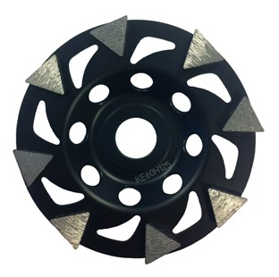
Toepassing | Beton, epoxy, tegellijm
Diameters Ø | 125-150-180
Asgat | 22,23

B7371803 | Delta-Cup wheel 180 mm 6.0T X 8N
B7371503 | Delta-Cup wheel 150 mm 6.0T X 8N
B7371253 | Delta-Cup wheel 125 mm 6.0T X 8N

