

**CS 330**

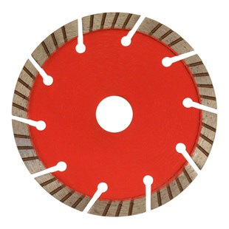

|  |  |
| --- | --- |
| Toepassing | Beton, baksteen, kalkzandsteen, dakpannen |
| Diameters Ø | 125-150-180-230 |
| Asgat | 22,23 |
| Segmenthoogte | 10 mm |
| Gebruik | Droog |

|  |  |
| --- | --- |
| 40116601252224 | Ø 125/22,23mm Pristis Turbo CS 330 29x2,2x10 10 Segm. rood |
| 40116601502224 | Ø 150/22,23mm Pristis Turbo CS 330 32x2,2x10 12 Segm. rood |
| 40116601802224 | Ø 180/22,23mm Pristis Turbo CS 330 33x2,2x10 14 Segm. rood |
| 40116602302226 | Ø 230/22,23mm Pristis Turbo CS 330 38x2,2x10 16 Segm. rood |