

**FKS+**

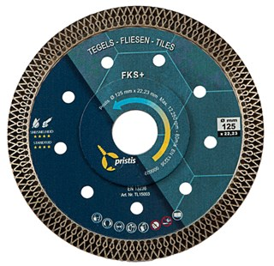

|  |  |
| --- | --- |
| **Artikelcode** | **Omschrijving** |
| TL15002 | 115/22,23 Pristis Tegels FKS+ 1,2x10mm Blank |
| TL15003 | 125/22,23 Pristis Tegels FKS+ 1,2x10mm Blank |