

**Gatzagensets (4/6) met Quick-lock**

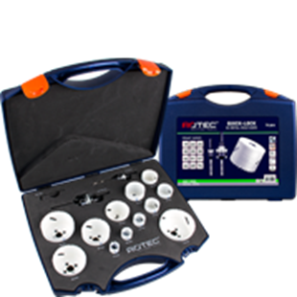

**BiM Gatzagensets (4/6) met Quick-Lock**

|  |  |  |  |  |
| --- | --- | --- | --- | --- |
| Art.nr. |  | Omschrijving | Type | Inhoud |
| 527.4105 |  | 10-dlg. Set HSS-BiMCo8 Gatzagenset "Loodgieter" | "527" | 1x ø19, 22, 27, 32, 35, 40, 51 en 64mm 1x Quick-Lock adapter 14-30mm (6-knt. 9) 1x Quick-Lock adapter 32-210mm (6-knt. 9) |
| 527.4110 |  | 10-dlg. Set HSS-BiMCo8 Gatzagenset "Elektricien" | "527" | 1x ø22, 27, 32, 35, 38, 44, 51, 68 en 76mm 1x Quick-Lock adapter 14-30mm (6-knt. 9) 1x Quick-Lock adapter 32-210mm (6-knt. 9) |
| 527.4125 |  | 14-dlg. Set HSS-BiMCo8 Gatzagenset "Allround" | "527" | 1x ø19, 22, 25, 32, 35, 38, 44, 51, 57, 64, 68 en 76mm 1x Quick-Lock adapter 14-30mm (6-knt. 9) 1x Quick-Lock adapter 32-210mm (6-knt. 9) |