

**Quick-lock adapters**

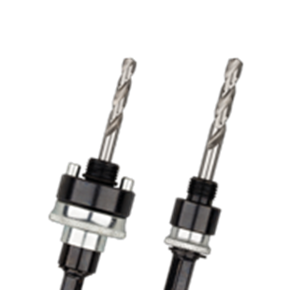

**Quick-Lock Adapters**

|  |  |  |  |  |  |
| --- | --- | --- | --- | --- | --- |
| Art.nr. |  | Nr. | Omschrijving | Schacht | Bereik (mm) |
| 527.3020 |  | 1 | Quick Adapter | 6-knt. 9 | 14-30 mm |
| 527.3021 |  | 2 | Quick Adapter | 6-knt. 9 | 32-210 mm |
| 527.3030 |  | 3 | Quick Adapter | SDS+ | 14-30 mm |
| 527.3031 |  | 4 | Quick Adapter | SDS+ | 32-210 mm |