

**Quick-lock centreerboren**

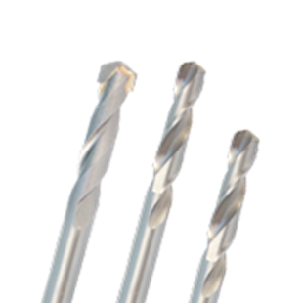

**Quick-Lock Centreerboren**

Uitvoering

Centreerboren t.b.v. Quick-Lock Adapter.

|  |  |  |  |  |  |
| --- | --- | --- | --- | --- | --- |
| Art.nr. |  | Nr. | Omschrijving | Gatzagen | Lengte |
| 527.3023 |  | 1 | HSS Centreerboor | 527.xxxx | 90mm |
| 527.3024 |  | 2 | HSS Centreerboor | 528.xxxx | 110mm |
| 527.3025 |  | 3 | HM Centreerboor | 528.xxxx | 110mm |