

**Quick-change adapters**

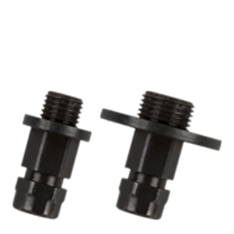

**Quick-Change Adapters**

Uitvoering

Quick Change adapters voor gatzagen.

|  |  |  |  |  |
| --- | --- | --- | --- | --- |
| Art.nr. |  | Omschrijving | Opname | VE |
| 528.3155 |  | Adapter | 1/2"-20 UNF | 1 |
| 528.3156 |  | Adapter | 1/2"-20 UNF | 5 |
| 528.3157 |  | Adapter | 1/2"-20 UNF | 10 |
| 528.3160 |  | Adapter | 5/8"-18 UNF | 1 |
| 528.3161 |  | Adapter | 5/8"-18 UNF | 5 |
| 528.3162 |  | Adapter | 5/8"-18 UNF | 10 |