

**Quick-change centreerboren (HM)**

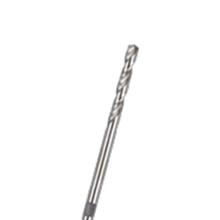

**Quick-Change Centreerboor (HM)**

|  |  |  |
| --- | --- | --- |
| Art.nr. |  | Omschrijving |
| 528.3140 |  | HM Centreerboor |