

**Etui**

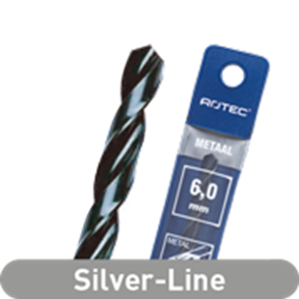

**HSS-R Spiraalboren, Silver-Line, in etui**

Uitvoering

HSS spiraalboren DIN 338, type N, rolgewalste uitvoering, stoomontlaten, tophoek 118°.

Toepassing

Algemeen gebruik, voor het boren in de meest voorkomende materialen, zoals staal en gietijzer.

|  |  |  |  |  |  |
| --- | --- | --- | --- | --- | --- |
| Art.nr. |  | Diameter | Totaal | Spiraal | V.E. |
| 100.0100B |  | 1,0 | 34 | 12 | 2 |
| 100.0150B |  | 1,5 | 40 | 18 | 2 |
| 100.0200B |  | 2,0 | 49 | 24 | 2 |
| 100.0250B |  | 2,5 | 57 | 30 | 2 |
| 100.0300B |  | 3,0 | 61 | 33 | 2 |
| 100.0310B |  | 3,1 | 65 | 36 | 2 |
| 100.0320B |  | 3,2 | 65 | 36 | 2 |
| 100.0330B |  | 3,3 | 65 | 36 | 2 |
| 100.0350B |  | 3,5 | 70 | 39 | 2 |
| 100.0400B |  | 4,0 | 75 | 43 | 2 |
| 100.0410E |  | 4,1 | 75 | 43 | 1 |
| 100.0420E |  | 4,2 | 75 | 43 | 1 |
| 100.0450E |  | 4,5 | 80 | 47 | 1 |
| 100.0480E |  | 4,8 | 86 | 52 | 1 |
| 100.0500E |  | 5,0 | 86 | 52 | 1 |
| 100.0510E |  | 5,1 | 86 | 52 | 1 |
| 100.0520E |  | 5,2 | 86 | 52 | 1 |
| 100.0550E |  | 5,5 | 93 | 57 | 1 |
| 100.0600E |  | 6,0 | 93 | 57 | 1 |
| 100.0650E |  | 6,5 | 101 | 63 | 1 |
| 100.0680E |  | 6,8 | 109 | 69 | 1 |
| 100.0700E |  | 7,0 | 109 | 69 | 1 |
| 100.0750E |  | 7,5 | 109 | 69 | 1 |
| 100.0800E |  | 8,0 | 117 | 75 | 1 |
| 100.0850E |  | 8,5 | 117 | 75 | 1 |
| 100.0900E |  | 9,0 | 125 | 81 | 1 |
| 100.0950E |  | 9,5 | 125 | 81 | 1 |
| 100.1000E |  | 10,0 | 133 | 87 | 1 |
| 100.1020E |  | 10,2 | 133 | 87 | 1 |
| 100.1050E |  | 10,5 | 133 | 87 | 1 |
| 100.1100E |  | 11,0 | 142 | 94 | 1 |
| 100.1150E |  | 11,5 | 142 | 94 | 1 |
| 100.1200E |  | 12,0 | 151 | 101 | 1 |
| 100.1250E |  | 12,5 | 151 | 101 | 1 |
| 100.1300E |  | 13,0 | 151 | 101 | 1 |