

**Losse boor**

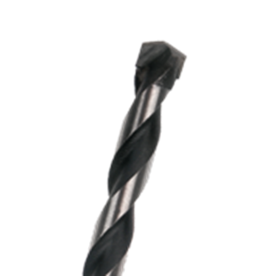

**Steenboor**

Uitvoering

Spaangroef met halfrond profiel.

Toepassing

Voor boorwerk in alle steensoorten.

|  |  |  |  |  |
| --- | --- | --- | --- | --- |
| Art.nr. |  | Diameter | Totaallengte | Spiraallengte |
| 225.0300 |  | 3,0 | 60 | 30 |
| 225.0400 |  | 4,0 | 75 | 40 |
| 225.0500 |  | 5,0 | 85 | 50 |
| 225.0600 |  | 6,0 | 100 | 60 |
| 225.0602 |  | 6,0 | 400 | 300 |
| 225.0700 |  | 7,0 | 100 | 60 |
| 225.0800 |  | 8,0 | 120 | 80 |
| 225.0802 |  | 8,0 | 400 | 300 |
| 225.0803 |  | 8,0 | 600 | 450 |
| 225.0900 |  | 9,0 | 120 | 80 |
| 225.1000 |  | 10,0 | 120 | 80 |
| 225.1002 |  | 10,0 | 400 | 300 |
| 225.1003 |  | 10,0 | 600 | 450 |
| 225.1100 |  | 11,0 | 120 | 80 |
| 225.1200 |  | 12,0 | 150 | 85 |
| 225.1202 |  | 12,0 | 400 | 300 |
| 225.1400 |  | 14,0 | 150 | 95 |
| 225.1401 |  | 14,0 | 400 | 300 |
| 225.1600 |  | 16,0 | 150 | 95 |
| 225.1601 |  | 16,0 | 400 | 300 |
| 225.1800 |  | 18,0 | 160 | 105 |
| 225.1801 |  | 18,0 | 400 | 300 |
| 225.2000 |  | 20,0 | 160 | 105 |
| 225.2001 |  | 20,0 | 400 | 300 |
| 225.2200 |  | 22,0 | 160 | 100 |
| 225.2201 |  | 22,0 | 400 | 300 |