Wasborstel dwars
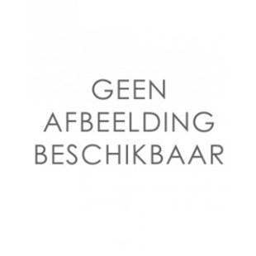
- borstelkop L240 x B90 mm
- max. 35 °C

