

**Cut bevel P150**

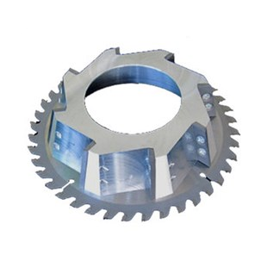

|  |  |
| --- | --- |
| Type | Cut bevel P150 |
| Afmetingen | 148 x 62 x 2.0/30.0 x 40/8 |
| Materiaal | Kunststof (PE, PP, PVC etc.) |
| Zaagmachine | P400 |