

**WD 10**

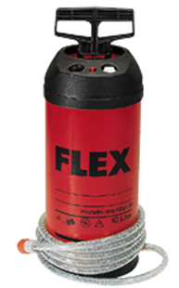

|  |  |  |  |  |  |  |  |  |
| --- | --- | --- | --- | --- | --- | --- | --- | --- |
| |  | | --- | | Technische attributen | | Vermogen | 10 l | | Gewicht | 4,5 kg |  |  | | --- | | Basisuitrusting | | 4 m drukslang | 252.317 | |
| Waterdrukvat 10 l   * Werkdruk 6 bar * Ideaal voor mobiele inzet * Past op alle machines met snelkoppeling ½“ water | |