

**BL18004**

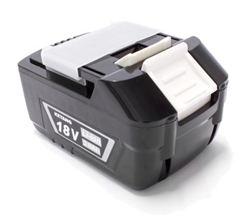

**Kenmerken BL18004 - Accu 18V 3.0Ah**

- Voltage - 18V  
- Amperage - 3.0Ah  
- Type - Li-Ion.