

**BL18011**

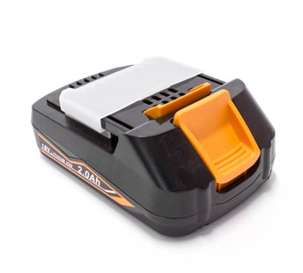

**Kenmerken BL18011- Accu 18V 2.0Ah**

- Voltage - 18V  
- Amperage - 2.0Ah  
- Type - Li-Ion.