

**BL36002**

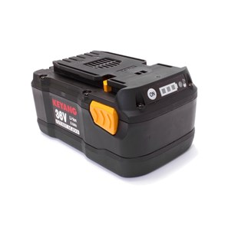

**Kenmerken BL36002 - Accu 36V 3.0Ah**

- Voltage - 36V  
- Amperage - 3.0Ah  
- Type - Li-Ion.