

**C14439**

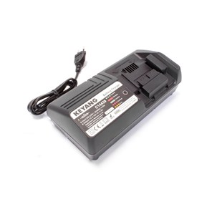

**Kenmerken C14439 - Lader 14.4-18V**

- Voltage - 14.4-18V  
- Type - Li-Ion.