

**HD16**

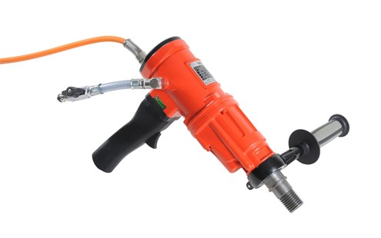

|  |  |
| --- | --- |
| Spanning (V) | 230 |
| Gewicht (Kg) | 6.2 |
| Toerental | 630/1400/2900 |
| Max. boordiameter statief (mm) | 20-150 |
| Max. boordiameter hand (mm) | 20-100 |
| Vermogen (W) | 3700 |
| Opname | 1/2;1 1/4 |
| Lengte (mm) | 375 |
| Toepassing | Steen, Beton |