

**DK18**

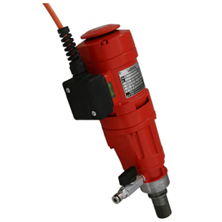

|  |  |
| --- | --- |
| Spanning (V) | 230 |
| Gewicht (Kg) | 5.9 |
| Toerental | 540/1200/2520 |
| Max. boordiameter (mm) | 160 |
| Vermogen (W) | 2000 |
| Opname | 1/2;1 1/4 |
| Lengte (mm) | 350 |
| Toepassing | Steen, Beton |