

**SR65 Jumbo**

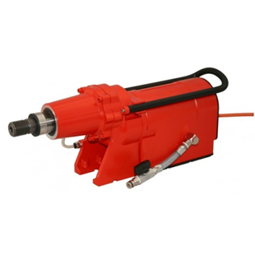

|  |  |
| --- | --- |
| Spanning (V) | 380 |
| Gewicht (Kg) | 18.3 |
| Toerental | 140/175/205/240/270/305 |
| Max. boordiameter (mm) | 500 |
| Vermogen (W) | 7500 |
| Opname | 1.25 |
| Lengte (mm) | 515 |