RS38
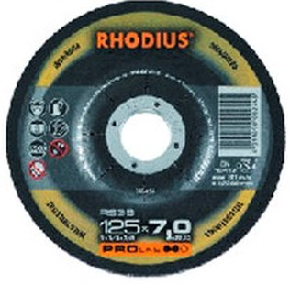
RS38 A24S8BF1339
115 x 7,0 x 22,23 |  | 25 | 200432
125 x 4,0 x 22.23 |  | 25 | 205681
125 x 7,0 x 22,23 |  | 25 | 200451
150 x 7,0 x 22,23 |  | 10 | 205714
180 x 7,0 x 22,23 |  | 10 | 200442
230 x 7,0 x 22,23 |  | 10 | 200466
Toepassing: RVS

