XT70
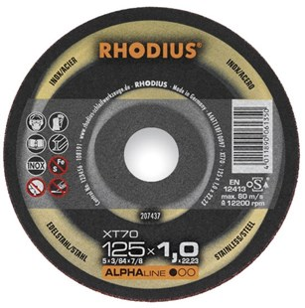
Ideaal voor machines met gering vermogen
XT70 A46T11BF10097
115 x 1,0 x 22,23 | 50 | 209041
115 x 1,0 x 22,23 | 100 | 207436
115 x 1,5 x 22,23 | 100 | 207438
125 x 1,0 x 22,23 | 50 | 209042
125 x 1,0 x 22,23 | 100 | 207437
125 x 1,5 x 22,23 | 100 | 207439

XTK70 A46T11BF11058
150 x 1,0 x 22,23 | 25 | 209511
180 x 1,5 x 22,23 | 25 | 208121
230 x 1,9 x 22,23 | 25 | 208122
Toepassing: RVS

