FT26
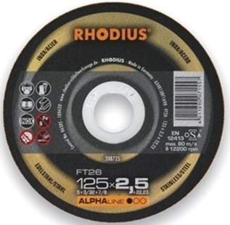
FT26 A24R13BF11698
115 x 2,0 x 22,23 | 25 | 208724
125 x 2,0 x 22,23 | 25 | 208725
180 x 2,0 x 22,23 | 25 | 208726
230 x 2,5 x 22,23 | 25 | 208727

FTK26 A24R13BF11698
115 x 2,0 x 22,23 | 25 | 208728
125 x 2,0 x 22,23 | 25 | 208729
180 x 2,0 x 22,23 | 25 | 208730
230 x 2,5 x 22,23 | 25 | 208731
Toepassing: RVS

