FT44
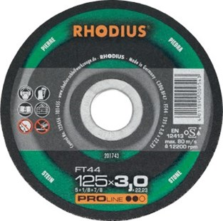
FT44 C30Q-BF47
100 x 2,5 x 16.00 | 25 | 201737
115 x 3,0 x 22.23 | 25 | 201750
125 x 3,0 x 22.23 | 25 | 201743
180 x 3,0 x 22.23 | 25 | 201764
230 x 3,0 x 22.23 | 25 | 201788

FTK44 C30Q-BF48
100 x 2,0 x 16.00 | 25 | 201804
115 x 3,0 x 22.23 | 25 | 201810
125 x 3,0 x 22.23 | 25 | 201838
150 x 3,0 x 22.23 | 25 | 201863
180 x 3,0 x 22.23 | 25 | 201867
230 x 3,0 x 22.23 | 25 | 201873
Toepassing: steen

