LSA P1
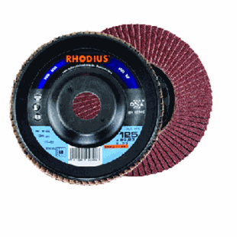
Polyamide drager
LSAP1
115 x 22.23 | 13285 | 40 | 10 | 202475
115 x 22.23 | 13285 | 60 | 10 | 202481
115 x 22.23 | 13285 | 80 | 10 | 202487
115 x 22.23 | 13285 | 120 | 10 | 202493
125 x 22.23 | 12200 | 40 | 10 | 202591
125 x 22.23 | 12200 | 60 | 10 | 202595
125 x 22.23 | 12200 | 80 | 10 | 202599
125 x 22.23 | 12200 | 120 | 10 | 202603
Toepassing: staal

