LSZ F2 Value pack 40+
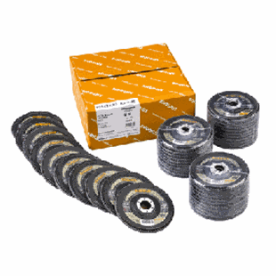
LSZ F2 VALUE PACK 40+
115 x 22.23 | 13285 | 40 | 40 | 208408
115 x 22.23 | 13285 | 60 | 40 | 208409
115 x 22.23 | 13285 | 80 | 40 | 208410
125 x 22.23 | 12200 | 40 | 40 | 208411
125 x 22.23 | 12200 | 60 | 40 | 208412
125 x 22.23 | 12200 | 80 | 40 | 208413
Toepassing: RVS

