LSZ P1
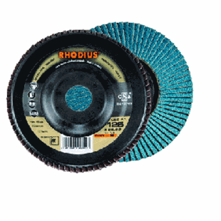
LSZP1
115 x 22.23 | 13285 | 24 | 10 | 202517
115 x 22.23 | 13285 | 40 | 10 | 202523
115 x 22.23 | 13285 | 60 | 10 | 202531
115 x 22.23 | 13285 | 80 | 10 | 202539
115 x 22.23 | 13285 | 120 | 10 | 202547
125 x 22.23 | 12200 | 40 | 10 | 202610
125 x 22.23 | 12200 | 60 | 10 | 202618
125 x 22.23 | 12200 | 80 | 10 | 202626
180 x 22.23 | 8600 | 40 | 10 | 202559
180 x 22.23 | 8600 | 60 | 10 | 202567
180 x 22.23 | 8600 | 80 | 10 | 202573
Toepassing: RVS

