

**Adapter rubber Ø 32 - Ø 38**

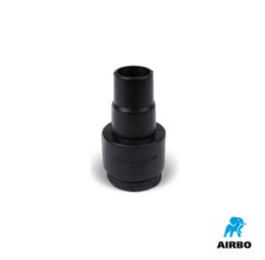

Adapter rubber ø32-ø38mm

– Bestelnummer: 500609