

**Banana pipe cleaning tool**

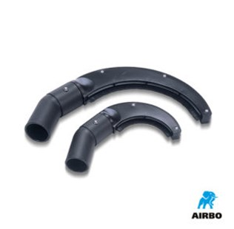

Banana pipe cleaning tool

– Banana pipe cleaning tool 100mm | 500597  
– Banana pipe cleaning tool 200mm | 500418