

**Set 4 adapters in tas**

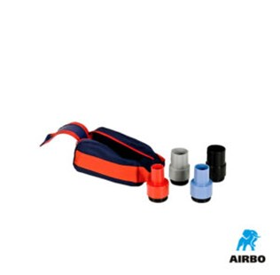

Set 4 adapters in tas

– Alle 4 adapters met opbergtas  
– Bestelnummer: 500316