Boor-unit
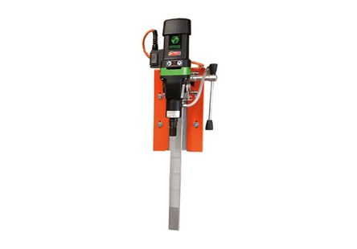
17F015
Scorpione - Compact - Eco - Manta Automatica - Manta Special

