Compact 200-250-300
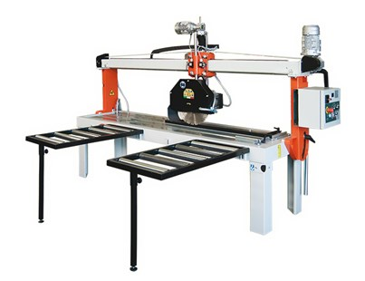

Technical Data
ITEM | MOD. | 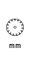 |  | 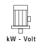 | 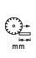 | 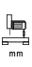 | 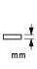 | 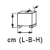
150900 | FRESA MANTA 200 COMPACT MANUALE | 350 - 25.4 | 2800 | 3 - 400* | 2000 | 250 | 110 | 290x91x121 | 237
150911 | FRESA MANTA 200 COMPACT MANUALE | 450 - 30 | 1400 | 4 - 400* | 2000 | 250 | 150 | 290x91x121 | 290
150920 | FRESA MANTA 200 COMPACT SEMI AUTOMATICA | 350 - 25.4 | 2800 | 3 - 400* | 2000 | 250 | 110 | 314x91x121 | 250
150931 | FRESA MANTA 200 COMPACT SEMI AUTOMATICA | 450 - 30 | 1400 | 4 - 400* | 2000 | 250 | 150 | 314x91x121 | 305
150901 | FRESA MANTA 250 COMPACT MANUALE | 350 - 25.4 | 2800 | 3 - 400* | 2500 | 250 | 110 | 340x91x121 | 260
150912 | FRESA MANTA 250 COMPACT MANUALE | 450 - 30 | 1400 | 4 - 400* | 2500 | 250 | 150 | 340x91x121 | 315
150921 | FRESA MANTA 250 COMPACT SEMI AUTOMATICA | 350 - 25.4 | 2800 | 3 - 400* | 2500 | 250 | 110 | 364x91x121 | 280
150932 | FRESA MANTA 250 COMPACT SEMI AUTOMATICA | 450 - 30 | 1400 | 4 - 400* | 2500 | 250 | 150 | 364x91x121 | 335
150902 | FRESA MANTA 300 COMPACT MANUALE | 350 - 25.4 | 2800 | 3 - 400* | 3000 | 250 | 110 | 390x91x121 | 300
150913 | FRESA MANTA 300 COMPACT MANUALE | 450 - 30 | 1400 | 4 - 400* | 3000 | 250 | 150 | 390x91x121 | 350
150922 | FRESA MANTA 300 COMPACT SEMI AUTOMATICA | 350 - 25.4 | 2800 | 3 - 400* | 3000 | 250 | 110 | 414x91x121 | 315
150933 | FRESA MANTA 300 COMPACT SEMI AUTOMATICA | 450 - 30 | 1400 | 4 - 400* | 3000 | 250 | 150 | 414x91x121 | 365
* Single phase also available - 2.2 kW - 2800/1400 RPM.
