ED 65-85-100-120-150
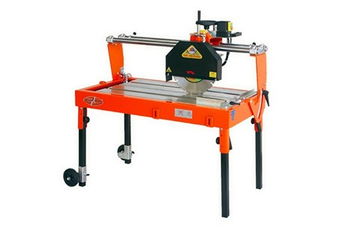

Technical Data
ITEM | MOD. |  |  | 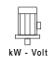 | 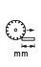 | 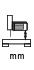 | 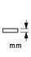 | 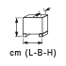
120150ED | MANTA 65 | 350 | 2800 | 2,2 - 230* | 650 | 130 | 110 | 107x66x77 | 90
120200ED | MANTA 85 | 350 | 2800 | 2,2 - 230* | 850 | 130 | 110 | 127x66x77 | 105
120250ED | MANTA 100 | 350 | 2800 | 2,2 - 230* | 1000 | 130 | 110 | 140X66X77 | 120
120300ED | MANTA 120 | 350 | 2800 | 2,2 - 230* | 1200 | 130 | 110 | 160x66x77 | 160
120350ED | MANTA 150 | 350 | 2800 | 2,2 - 230* | 1500 | 130 | 110 | 197x66x77 | 180
* 3 kW - triphase version is also available

