Inox 120-150-200 LX
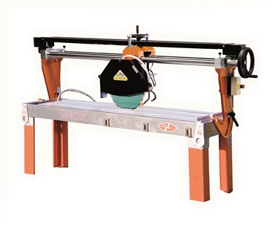

Technical Data
ITEM | MOD. | 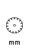 |  | 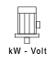 | 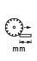 | 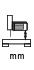 | 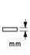 | 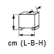 | 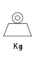
120282 | MANTA INOX 120 LX** | 350 | 2800 | 2,6-230* | 1200 | 180 | 110 | 195x66x87 | 190
120279 | MANTA INOX 150 LX | 450 | 2800 | 4-400 | 1500 | 180 | 150 | 218x66x87 | 190
120265 | MANTA INOX 150 LX GRANIT | 450 | 1400 | 2,2-230* | 1500 | 180 | 150 | 218x66x87 | 220
120281 | MANTA INOX 150 LX GRANIT | 450 | 1400 | 4-400 | 1500 | 180 | 150 | 218x66x87 | 220
120264 | MANTA INOX 200 LX** | 350 | 2800 | 2,6-230* | 2000 | 180 | 110 | 275x66x87 | 240
120268 | MANTA INOX 200 LX GRANIT | 450 | 1400 | 2.2-230 | 2000 | 180 | 150 | 275x66x87 | 250
120278 | MANTA INOX 200 LX GRANIT | 450 | 1400 | 5,5-400 | 2000 | 180 | 150 | 275x66x87 | 250
* Triphase version in also available
** Self-bracking motor

