Laser (2)
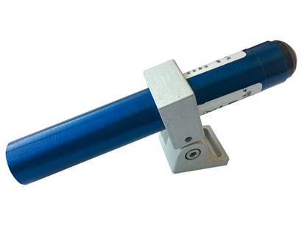

Technical Data
ITEM | MW | BATT
020092 | 1 | STILO AA
020078* | 1 | STILO AA
020674** | 5 | STILO AA
Mounting bracket
* with holder. ** 5mW green diode.

