Long diagonal square
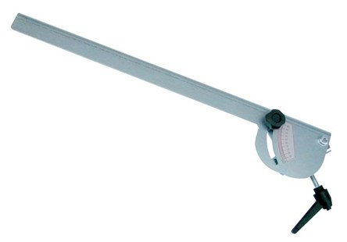

Technical Data
ITEM | AVAILABLE ON
17M004 | All models

